Q1. Explain **TWO (2)** primary responsibilities of transport layer protocols.

*(201605 TAR UC, resit)* (4 marks)

* Two primary responsibilies of transport layer protocols
  + **Tracking** the **individual communication** between applications on the source and destination hosts.
  + **Segmenting data** for manageability and reassembling segmented data into streams of application data at the destination
  + **Identifying** the process **application** for each communication stream

Q2. Compare well-known ports with registered port numbers. *(201609 TAR UC, Main)* (6 marks)

|  |  |
| --- | --- |
| Well-known Ports | Registered Port Numbers |
| 5-1023 | 1024-49151 |
| Reserved for services / applications. | Assigned to user processes / applications |
| Ports with specific purpose. Client application connects to it to use service. | Ports without specific purpose. Used by user applications. |

Q3. With reference to Figure 2, express in your own words the meaning of the output labelled A, B, C and D. *(201409 TAR UC, Main)* (4 marks)

A: Source Port

B: Address or name of remote host

C: Destination port

D: Connection status

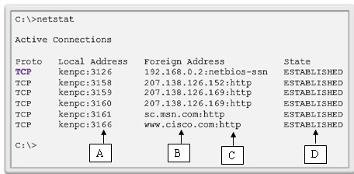

Figure 2: TCP connections running on a networked host

Q4. Figure 1 is showing an output by using a command prompt of a host.

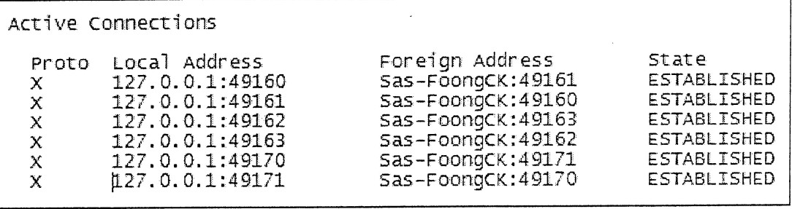

Figure 1: Connection status of a host

1. What is the command that can be used to have an output of Figure 1?

*(201705 TAR UC, resit)* (2 marks)

netstat

1. What is the protocol name that is labelled as X in Figure 1? *(201705 TAR UC, resit)*
   * *Transmission Control Protocol (TCP)*

(1 mark)

Transmission Control Protocol (TCP)

1. Provide **TWO (2)** applications or services that are supported by the protocol that you have answered in Question 4 (ii). *(201705 TAR UC, resit)* (2 marks)

E-mail applications (SMTP/POP/IMAP)

File transfer (FTP)

Web browsing (WWW/HTTP/HTTPS)

Database

Telnet

Domain Name Server (DNS)

1. Give **ONE (1)** example of a port number according to Figure 1.

*(201705 TAR UC, resit)* (1 mark)

Port numbers:

* 49160
* 49161
* …

Q5. During a connection establishment, TCP0 opens a connection using an initial sequence number (ISN) of 4918. The other party, TCP1, opens the connection with an ISN of 24463. In data transfer phase, the TCP0 sends only one segment with data size of 1000 bytes. Then it sends a FIN segment to close the connection.

1. Draw a three-way handshake diagram to show the values of sequence number and acknowledgment number for the three Transmission Control Protocol (TCP) segments during the connection establishment. *(201703 TAR UC, resit)* (8 marks)

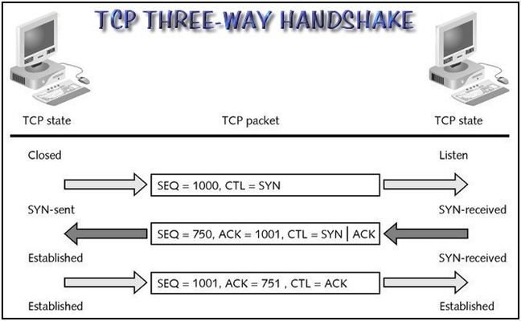

1. TCP provides mechanisms for flow control. List and explain the field in TCP header that uses for flow control. *(201703 TAR UC, resit)* (5 marks)

* To accomplish flow control, the TCP header includes a 16-bit field called the window size.
* This is the number of bytes that the destination device of a TCP session is able to accept and process at one time.

Q6. Briefly describe TWO (2) benefits of using User Datagram Protocol (UDP) as the transport layer protocol. *(201705 TAR UC, resit)* (4 marks)

* **Lower overhead**. 8 bytes only.
* **Fast** because no retransmission of lost messages and it’s connectionless.
* Supports **real time applications** such as VoIP, audio, video, and online games.

Q7. Transmission Control Protocol/Internet Protocol (TCP/IP) provides two transport layer protocols, Transmission Control Protocol (TCP) and User Datagram Protocol (UDP).

* 1. Discuss **TWO (2)** characteristics of UDP. *(201609 TAR UC, Main)* (4 marks)
* **Connectionless** – UDP does not establish a connection between the hosts before data can be sent an received
* **Unreliable delivery** – UDP does not provide services to ensure that the data will be delivered reliably. There are no processes within UDP to have the sender retransmit any data that is lost or corrupted.
* **No Ordered Data Reconstruction** – Occasionally, data is received in a different order than it was sent. UDP does not provide any mchanism for reassembling the data in its original sequence. The data is simply delivered to the application in the order that it arrives.
* **No Flow Control** – There are no mechanisms within UDP to control the amount of data transmitted by the source to avoid overwhelming the destination device. The source sends the data. If resources on the destination host becomes overtaxed, the destination host most likely drops data sent until resources become available. Unlike TCP, with UDP there is no mechanism for automatic retransmission of dropped data.
  1. With the aid of a diagram, illustrate FOUR (4) steps of TCP termination process.

*(201609 TAR UC, Main)* (11 marks)

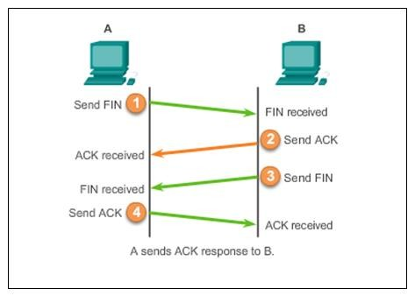

Step 1: When the client has no more data to send in the stream, it sends a segment with the FIN flag set.

Step 2: The server sends an ACK to acknowledge the receipt of the FIN to terminate the session from client to server.

Step 3: The server sends a FIN to the client, to terminate the server to client session.

Step 4: The client responds with an ACK to acknowledge the FIN from the server.

Q8. In the transport layer, the main protocols used are Transmission Control Protocol (TCP) and User Datagram Protocol (UDP).

1. Compare and contrast these two protocols. You are required to provide FOUR (4) sets of comparisons. *(201703 TAR UC, resit)* (8 marks)

|  |  |
| --- | --- |
| Transmission Control Protocol (TCP) | User Datagram Protocol (UDP) |
| Connection-oriented protocol. A connection is established before data exchange. | UDP is a simple, connectionless protocol because sessions are not established before communication takes place. |
| A TCP segment (piece) is called a segment. | A UDP segment (piece) is called a datagram. |
| A TCP header provies source and destination (ports), sequencing, acknowledgements, and flow control. | A UDP header provides source and destination (ports). |
| TCP has a slower data transfer rate because it is more complex and has additional overhead | UDP has a faster data transfer rate because it is simpler and has less overhead. |
| TCP incurs a high overheads 🡪 20 bytes of overhead | UDP has low-overhead |
| TCP is a protocol that guarantees reliable and in-order delivery of data from sender to receiver. | UDP sends datagrams as “Best Effort” (unreliable) |
| In TCP, each segment header contains a sequence number so that the segments can be reassembled in the order they were transmitted | In UDP, headers do not include sequence number because UD is not concerned with order of transmission |

1. Give **TWO (2)** applications using TCP protocol and give **TWO (2)** applications using UDP protocol. *(201703 TAR UC, resit)* (4 marks)

* Applications that use TCP:
* Hypertext Transfer Protocol (HTTP)
* File Transfer Protocol (FTP)
* Simple Mail Transfer Protocol (SMTP)
* Telnet
* HTTPS
* IRC
* POP3
* Applications that uses UDP:
  + Domain Name System (DNS)
  + Dynamic Host Configuration Protocol (DHCP)
  + Video Streaming
  + Voice over IP (VoIP)
  + Online games
  + Simple Network Management Protocol (SNMP)
  + Trivial File Transfer Protocol (TFTP)

Q9. Provide **TWO (2)** reasons why User Datagram Protocol (UDP) is suitable as a transport layer protocol for applications such as online multiplayer gaming. *(201503 TAR UC, resit)*

* Speed is more important than reliability. *Some loss can be tolerated in online games, but slight delay will impact the game outcome.*
* *If TCP is used, time checking and retransmitting corrupted packets causes a large delay in transfer. By the time the retransmission succeeds, the information presented to the user will be delayed too much to be useful.*

Q10. Transmission Control Protocol/Internet Protocol (TCP/IP) suite provides two transport layer protocols, Transmission Control Protocol (TCP) and User Datagram Protocol (UDP). (*201709 TAR UC main*)

* 1. Provide any **FOUR (4)** comparisons between TCP and UDP. (8 marks)

|  |  |
| --- | --- |
| 1. Transmission Control Protocol (TCP) | User Datagram Protocol (UDP) |
| Connection-oriented protocol. A connection is established before data exchange. | UDP is a simple, connectionless protocol because sessions are not established before communication takes place. |
| A TCP segment (piece) is called a segment. | A UDP segment (piece) is called a datagram. |
| A TCP header provies source and destination (ports), sequencing, acknowledgements, and flow control. | A UDP header provides source and destination (ports). |
| TCP has a slower data transfer rate because it is more complex and has additional overhead | UDP has a faster data transfer rate because it is simpler and has less overhead. |
| TCP incurs a high overheads 🡪 20 bytes of overhead | UDP has low-overhead |
| TCP is a protocol that guarantees reliable and in-order delivery of data from sender to receiver. | UDP sends datagrams as “Best Effort” (unreliable) |
| In TCP, each segment header contains a sequence number so that the segments can be reassembled in the order they were transmitted | In UDP, headers do not include sequence number because UD is not concerned with order of transmission |

* 1. Discuss **TWO (2)** advantages of using UDP as compared to TCP. (4 marks)
* Two advantages:
  + **UDP is faster**. UDP is connectionless, therefore, does not require extra time to establish connection.
  + **UDP has less overhead.** UDP does not send any acknowledgements or retransmit data. Less resources are used for UDP transmission.
  1. State **THREE (3)** applications that uses TCP. (3 marks)
* Three applications:
  + Hypertext Transfer Protocol (HTTP)
  + File Transfer Protocol (FTP)
  + Simple Mail Transfer Protocol (SMTP)
  + Telnet